Feedback and Bug report based on the web page [https://qa-task.immedis.com](https://qa-task.immedis.com/)

**Login page:**

* Successful login with empty or incorrect credentials;
* Sign up button does not respond when clicked – no action is executed;
* Forgotten password link redirects to not found page with code 404;

**Users page:**

* The main menu on Users page is unevenly formatted;
* There is “Index” text on page that is not relevant to the content;
* “Create New” link is not clear what is going to be created, it should be e.g. “Create New User”;
* The Library button is bigger than the others on the main menu;
* The table with Users is unevenly formatted – there is column name only for Name;
* The column Name is too big, it should be restricted to max width;
* The edit, details and delete columns are not formatted, there is no column name for them;
* Edit link redirects to not found page with code 404;
* Delete link redirects to a “broken” page with some json formatted text on it;

**Create new user page:**

* Name field is mandatory but there is no error message shown when it’s left empty. Error occurred instead;
* When name exceeds the limit of 100 symbols no error message is shown but error occurred instead;
* “Back to list” link could be more clear – “Back to users list”;
* Users with same name can be created multiple times, need to add an unique identifier like email or username;

**User details page:**

* Formatted unevenly;

**Edit page from details page:**

* There is value inside the Name field, could be better if it is empty;
* Same validations for empty field and exceeding limits like on Create new user page;

**Books page:**

* Same comments related to table formatting and columns;
* Same comment related to “Index” text on the page;
* Same comment related to “Create New” button;
* Quontity is misspelled;

**Create new book page:**

* Quontity is misspelled;
* All fields should be mandatory, but only Quantity is;
* Validations for exceeding the limits for all fields throw error;
* Quantity should be positive number, but there is no validation;
* Same comment related to “Back to list”;
* Same book with details can be created more than once;

**Edit book page:**

* There are values in all fields, they should be empty;
* Same validation errors as on create page – related to empty fields and exceed limitations;

**Details and Delete book page:**

* Could be better formatted;

**Get book page:**

* Same comments related to formatting, columns, ”Index” and “Create New” link;

**Create new get book request:**

* Instead of User and Book name fields there are UserId and BookId;
* The dropdown for book is containing author names;
* Same about “Back to list”;
* The quantity of the book is not decreased due to the error with Book name/author mixed up;

**Edit get book request:**

* There should not be Date taken field on the page;
* Same comments related to UserId and BookId, also the value of Book;
* Same about “Back to list”;

**Details and Delete get book page:**

* Could be better formatted;
* When a get book request is deleted successfully, the quantity is not changed due to the error with Book name/author mixed up;
* Date taken is shown again (it is not mentioned in the specification that there is such field on the page);

================================================================================================================================================

**Title**: Sign in possible with empty or wrong credentials

**Issue description**: When trying to sign in on the [https://qa-task.immedis.com](https://qa-task.immedis.com/) with empty or wrong credentials it is possible to proceed successfully.

**Steps to reproduce**:

1. Open the page [https://qa-task.immedis.com](https://qa-task.immedis.com/)
2. Leave the username and/or password empty (or enter incorrect credentials)
3. Click the sign in button
4. Observe that the system allows to proceed to the next step, such as redirecting to the Users page

**Expected behavior**:

When an empty or incorrect credentials are entered, the system should not allow to proceed further. Error message with some information should be provided.

**Actual behavior**:

The system allows the user to proceed to the next step, even when empty or incorrect credentials are provided. No error message is displayed to indicate the invalid credentials.

**Severity**: High

**Priority**: High

**Environment**:

Application version: Production

Browser: Edge version 113

Operating system: Windows 10

**Title:** Deleting users button is not working

**Issue Description**: When trying to delete users from the system using the "Delete" button, it is observed that the functionality is not functioning as intended. The "Delete" button redirects to the broken page and fails to remove users from the system, resulting in the inability to perform user deletions effectively.

**Steps to reproduce**:

1. Log in to [https://qa-task.immedis.com](https://qa-task.immedis.com/) with valid credentials
2. Navigate to Users section
3. Click the “Delete” button associated with the selected user
4. The page which is opened is broken(see screenshot attached) and there is no confirmation for deletion of the user
5. Refresh the Users section to verify if the user has been deleted but find that the user is still present in the list

**Expected behavior**:

Clicking the "Delete" button should initiate the deletion process for the selected user and confirmation should be shown on the redirected page. The user should be removed from the system and we should not see it in the list on Users page.

**Actual behavior**:

Clicking the "Delete" button does not result in the deletion of the user. The user remains in the system, and no confirmation or success message is shown but the redirected page is broken.

**Severity**: High

**Priority**: Medium

**Attachments**: 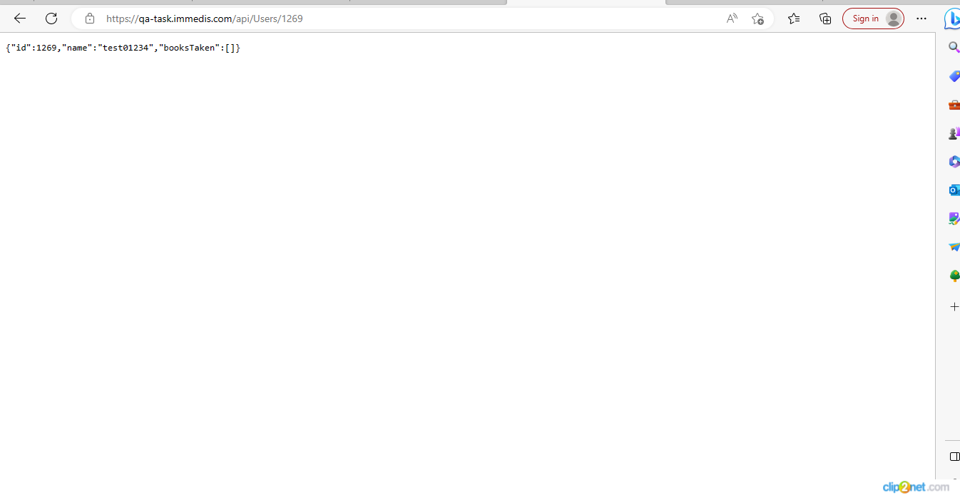

**Environment**:

Application version: Production

Browser: Edge version 113

Operating system: Windows 10

**Title**: Sign up button is not responsive

**Issue description**: The “Sign up” button on the login page is not responsive when clicked. If someone attempt to register in order to use the system, the user is unable to proceed due to the lack of responsiveness in the “Sign up” button.

**Steps to reproduce**:

1. Open the page [https://qa-task.immedis.com](https://qa-task.immedis.com/)
2. Click the button “Sign up”
3. Note that the “Sign up” button is not respond and it is not redirect on Registration page

**Expected behavior**:

Clicking the “Sign up” button should redirect to the Registration page where user can proceed with the registration process.

**Actual behavior**:

Clicking the “Sign up” button does not trigger any action.

**Severity:** Medium

**Priority**: Medium

**Environment**:

Application version: Production

Browser: Edge version 113

Operating system: Windows 10

**Comments regarding API requests in Postman:**

* In the specification is written that I should prepare test cases(requests) in Postman, but they were already prepared, so I just put some test data and test them;
* I change the url to <https://qa-task.immedis.com:443/api> because I saw in console that requests are sent to that url;
* When creating new user the response code is 200, shouldn’t be 201 ?
* The same user could be created many times with different id;
* All put and delete requests return 405 response code – method not allowed;
* Take a book request creates request with userId and BookId, on the site it is created with author name and user name;
* When execute get all books taken request, the book and user are null in the response;
* When I put url <http://qa-task.immedis.com/api> (as it was when I extracted the collection) put and delete requests return 200 ok, but underneath(in the console) I see that get request is executed to the https url above. Nothing is changed/deleted as put and delete are not actually executed, so I have used the https url for automation tests also.